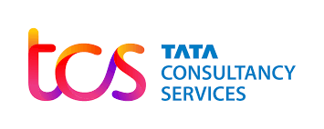

**General Overview**

Tata Consultancy Services Ltd is a leading global IT services, consulting and business solutions organization offering transformational as well as outsourcing services to global enterprises. They have a global presence, deep domain expertise in multiple industry verticals and a rich portfolio of services - consisting of consulting and service integration, digital transformation services, and cognitive business operations - targeting every C-suite stakeholder. The Company uses all these, and its industry leading suite of products and platforms to deliver high quality, high impact solutions leveraging the latest technologies to customers across the world.

TCSs geographic footprint consists of North America, Latin America, the United Kingdom, Continental Europe, Asia-Pacific, India and Middle-East & Africa. The company is a part of Tata Group, one of India’s most respected business conglomerates and most respected brands. The company headquartered in Mumbai. TCS have been operating through 285 offices in 46 countries as well as 147 delivery centres in 21 countries. The company shares are listed on the National Stock Exchange and Bombay Stock Exchange of India. Tata Consultancy Services Ltd was incorporated in the year 1968. Tata Sons Ltd established the company as division to service their electronic data processing (EDP) requirements and provide management consulting services.

**Shareholding Pattern of the company**

The Shareholding Pattern page of Tata Consultancy Services Ltd. presents the Promoter's holding, Foreign Institutions Investment’s (FII) holding, Domestic Institutions Investment’s (DII) holding, and Shareholding by general public etc.

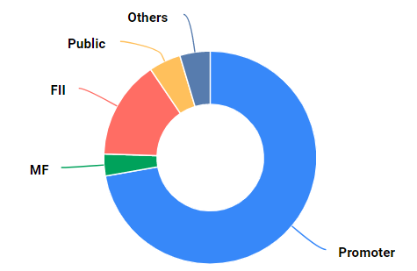 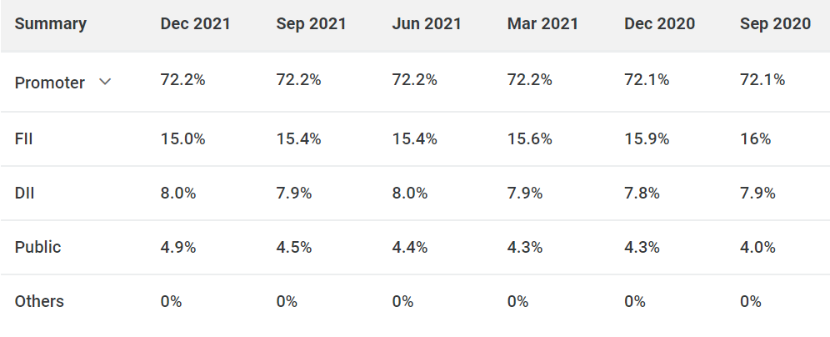

**Management of the company**



**Rajesh Gopinathan (Chief Executive Officer & Managing Director)**

Rajesh Gopinathan is the Chief Executive Officer and Managing Director of Tata Consultancy Services (TCS), a leading global IT solutions and consulting firm. He was elevated to the role of Chief Executive in February 2017 after serving as the Chief Financial Officer since 2013.

He has played a key role in helping TCS become a USD 20.9 billion global company. With over 424,000 consultants, TCS is one of the largest private sector employers globally and was recognised as a Global Top Employer for the third consecutive year, with the highest retention rate in a competitive industry. Under Rajesh’s leadership, the market capitalisation of the company crossed USD 100 billion during April 2018, making TCS the most valuable company in India.  TCS was recognised as the fastest growing brand in the IT industry for 2019 and consolidated its position as one of the top 3 IT Services brands for the second year in a row. The brand value of TCS increased by 23 % this year and thus TCS entered the USD 12.8 billion club.

Prior to his role as Chief Financial Officer, Rajesh was the Vice President - Business Finance.



**N. Ganapathy Subramaniam (Chief Operating Officer & Executive Director)**

Subramaniam (NGS) is the Chief Operating Officer (COO) of TCS since February 2017. He is also an Additional Director and Chairman of Tata Elxsi Limited since November, 2014.

Prior to taking over the COO’s role he served as the Executive Vice President and Head of TCS Financial Solutions, a strategic business unit of TCS. In that role, he was responsible for steering the non-linear growth strategies, Products and Platform businesses of TCS for over five years.

He has held many key leadership positions in TCS across Client Delivery, Business Development, integration of businesses and Product Development. As head of Banking and Financial Services practice for TCS for close to five years, he was instrumental in consolidating TCS’s knowledge base, calibrating domain centric offerings, creating opportunities and laid the foundation for its verticalization.

**SWOT analysis of the company**

**1. Strengths of TCS**

Strengths are an organization’s distinct skills that offer it a competitive edge in gaining greater market share, attracting more customers, and maximising profitability. TCS’s strengths are listed below:

* Extensive Global Reach – TCS’s global reach, which currently extends from North America, the United Kingdom, Africa, Europe, and the Asia-Pacific regions, reflects the company’s efforts to obtain as much coverage as possible in diverse areas. TCS has a strong worldwide image thanks to its presence in a variety of geographical locations.
* Major number of Customers from various sectors – TCS supports customers in a wide range of industries, including banking, finance, retail, telecommunications, and media & entertainment. Exposure to different enterprises mitigates the hazards of over-dependence on a particular market or industry.
* Strong reputed Brand Image in the market – TCS has unquestionably created its own brand, image, and reputation; it keeps its consumers satisfied and acts as a sign of excellence.
* Well established strategic alliances – TCS has formed significant alliances with multinational companies all around the world. It collaborated with technology powerhouses such as Amazon, Adobe, Dell, Bosch, and HP, among others. Through these partnerships, TCS provides both technologically viable and creative commercial and tactical solutions.
* Robust Service Portfolio – TCS has a diverse service offering that includes application development and maintenance of Business Process Services (BPS), IT infrastructures, business intelligence, and more. A robust and diversified portfolio is drawn to various corporate clients.
* Empowered and encouraged employees – Through effective training and learning initiatives, a highly competent workforce has been created. TCS invests heavily in employee training and development, resulting in a staff that is not just highly competent but also driven to achieve greater success.
* Excellent returns on capital invested – TCS has an excellent track record of executing new projects and generating good returns on capital expenditure by establishing new income streams.

**2. Weaknesses of TCS**

Weaknesses are elements of a company or brand that need to be improved. The following are TCS’s significant flaws:

* Performance of Diligenta deteriorated – Diligenta, a TCS subsidiary, has consistently performed poorly. TCS’s bottom line is unlikely to improve rapidly as a result of the enterprise’s poor performance and hence has a negative effect.
* Legal Squabbles – TCS filed a lawsuit against Epic System in 2014 for suspected abuse of private information. TCS was found guilty in 2016 and was charged $940 million in damages. TCS objected to and rejected the higher competence’s decision. Such incidents have a negative impact on the company’s image.
* The product segment is not relatively impressive – While TCS does well by delivering the greatest services, its products aren’t what one would anticipate from a company of its kind. They do require some effort.

**3. Opportunities for TCS**

Opportunities are possible areas of emphasis for a firm to focus on in order to enhance outcomes, boost sales, and, eventually, profit.

* Emerging Interest in Cloud Computing – Digital technologies and high-speed internet access have evolved. In fact, spending on cloud services will rise at a CAGR of 19% over the next five years. Society is shifting towards cloud-based solutions. TCS has a robust cloud-based infrastructure and is thus prepared to capitalise on the created demand.
* M2M Solutions – Wireless and cable communications systems are both enabled by Machine to Machine (M2M) solutions. There are bright possibilities for M2M solutions in the future, and revenues are projected to be substantial. TCS offers a comprehensive variety of M2M services, allowing the need for M2M solutions to be met.
* Transformation of the Digital Universe – Because the world is becoming more digital, business forces are altering the digital economy. TCS’s primary goal is to digitally transform and deliver digital solutions. TCS could expect more expenditure on technology for digital transformation.
* Solutions for mobility – With a rising mobile worker population and the increased usage of sophisticated mobile devices, enterprise mobility solutions are expected to be driven by business applications. The demand for mobility solutions is latent and is expected to grow at a CAGR of 24.7 per cent through 2022. TCS is well-positioned to profit from its increased emphasis on the development of enterprise mobility solutions.

**4. Threats to TCS**

Threats are environmental elements that might have a negative impact on a company’s success. TCS’s threats include the following:

* Competition is fierce – IT firms such as Infosys, Wipro, Capgemini, Deloitte, Accenture, and others confront fierce rivalry. As a result, the industry is experiencing price wars and has a restricted market share.
* A high rate of attrition – The Indian IT sector has a high rate of turnover, which raises the expense of providing new workers with skills and leadership development and has a negative impact on the company’s reputation.
* The Constraints on Immigration – With immigration regulations, increasing H-1B visa fees, and changing political situations in the US, Indian IT firms are anticipated to suffer as they increase their costs and damage profitability, posing a risk to the sector.
* Large multinational corporations – Large multinational corporations are expanding into India and competing for a worldwide clientele.

**Competitive Analysis**

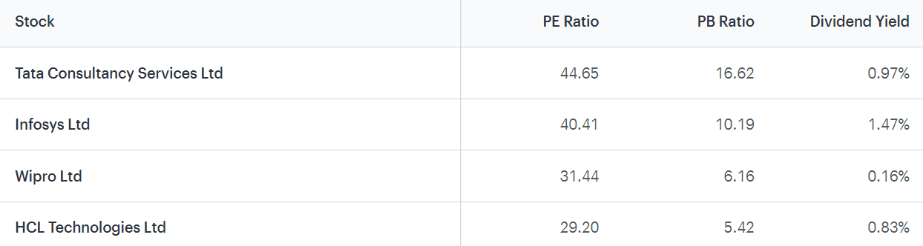

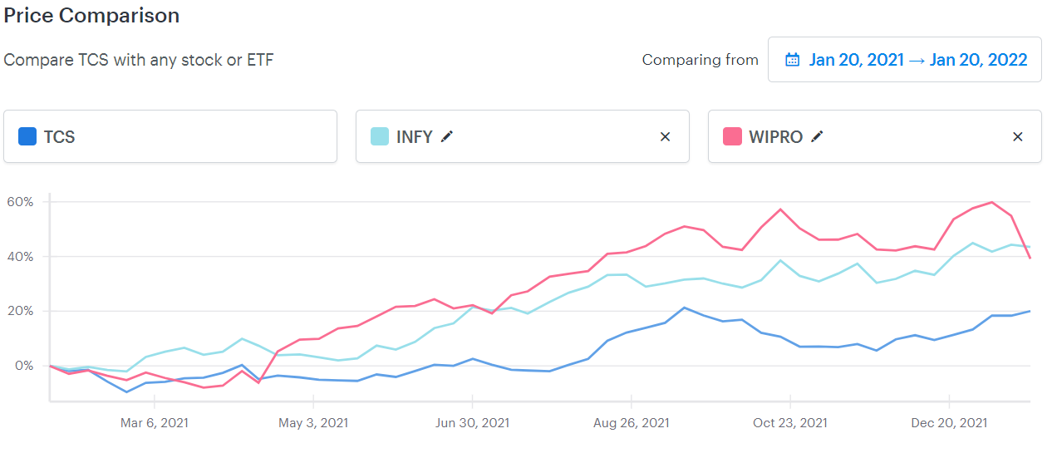

**Conclusion and way forward for the company**

TCS is unquestionably the best in its industry. It has numerous and noteworthy strengths. For a company like TCS with such a great brand image, brand backing, market command, portfolio, reach, and so on, it needs just a little more work to address its weaknesses and be more alert to threats. If TCS pays more attention to its strengths and expands as well as adjusts even further for new opportunities, TCS will be able to keep its crown.

Investment Checklist:

* Current price is more than the intrinsic value
* Stock has been generating better return on equity than bank FD
* Stock offers good dividend returns
* Good time to consider, as stock is not in overbought zone
* Stock not in ASM/GSM lists and not a lot of promoters holding is pledged

We also discovered in this SWOT Analysis of TCS that the firm is significantly reliant on its customers and has great brand recognition and trust. Considering the rising competition in a competitive field like IT, firms have to compete for their customers through improved marketing efforts.